**Troubleshooting for MAINTENANCE Mode**

Recently, many users encounter the issue that Micro:bit board doesn’t respond when connected to computer.

If the way you operate is correct, maybe you accidentally press the reset button and enter the Maintenance mode or lead to lose the firmware due to misoperation.

Plug in Micro:bit board, the“MAINTENANCE”drive appears. That means the program can’t be downloaded.  
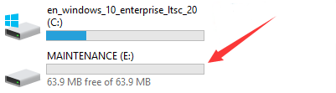

Note:

Download the **hex file** from this page to your computer.

Down load the latest firmware---0255:

<https://www.microbit.org/get-started/user-guide/firmware/>

1. After the latest firmware is downloaded, then drag it into the“MAINTENANCE”drive as follows, which makes Micro:bit come back to normal mode.

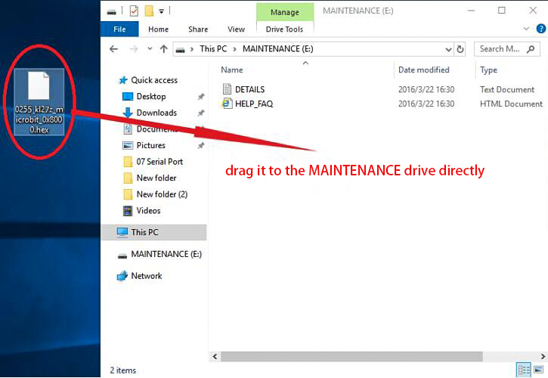

## ****How to avoid to enter“MAINTENANCE”mode ?****

1. When you connect a USB cable to the micro:bit, don’t press the reset button. Otherwise, the MAINTENANCE mode will be activated.

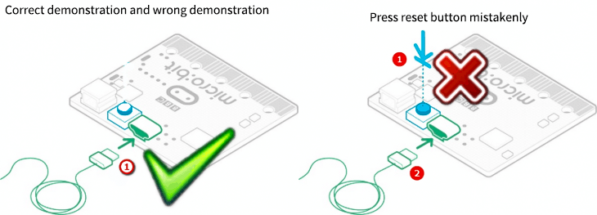

****06.png**** (163.12 KB, 下载次数: 26)

[下载附件](https://bbs.kittenbot.cn/forum.php?mod=attachment&aid=MjU5Mnw2ZTczNjdhZnwxNTk1ODE5Mjg4fDB8NDQy&nothumb=yes" \t "https://bbs.kittenbot.cn/_blank)

2018-12-2 13:38 上传

2. Don't unplug the cable suddenly when downloading the micro:bit program; otherwise, the firmware will be lost and“MAINTENANCE”mode will be activated.

3. In the experiment, wrong wiring-up also cause short circuit or loses the firmware.